Century Equities Hotel Project Meeting (former Washington Vo Tech) Meeting Notes
October 8, 2015
Pittsburgh Arsenal 6-8 Auditorium

Present: 50+ local residents, LU, LC, Century Equities, and Desmone Architects

- Copy of Project Sheet and Details Provided by the Lawrenceville Corporation:

169 40th Street

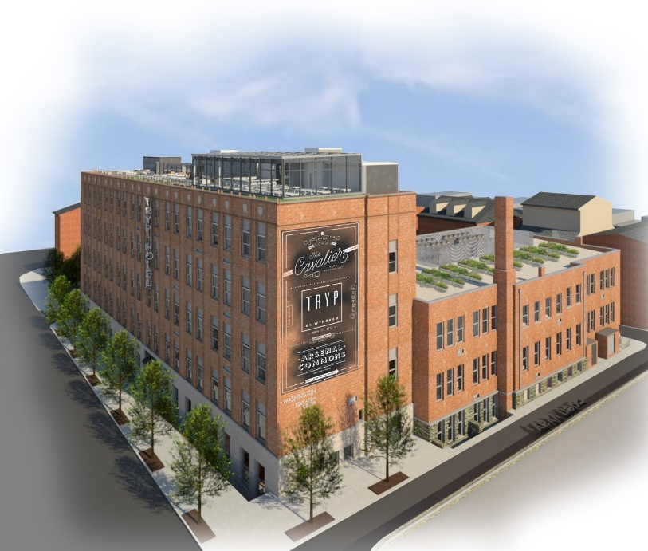 | 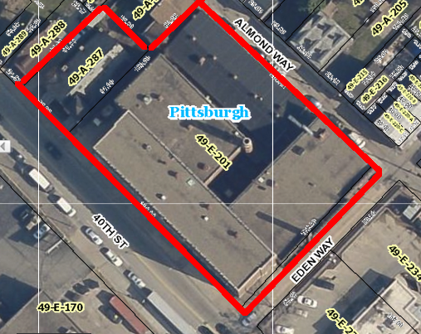

Project Summary: Developer: Century Equity
Project Architect: Desmone Architects
Property Information
Address: 169 40th Street
Lot and Block: 49-E-201 and 49-A-287
Lot Size: 37,950 SF
Zoning: UI

History: The project team has solicited significant feedback from LC’s Real Estate Committee.

Project overview: Plans call for the redevelopment of the existing buildings on 40th Street and Eden Way for conversion to a boutique hotel project with 107 rooms and 37 or 88 on-site parking spaces depending on site option. Pedestrian entrance will be along 40th Street and guest/car drop-off will be off of Almond Way. Demolition of the rear building on Almond Way is proposed. The hotel will also include restaurant/bar space. Any liquor licenses pursued at this site will be discussed in a separate community meeting according to LU and LC’s responsible hospitality framework.

Current Status: ZBA hearing scheduled for October 15th at 200 Ross Street 9:50 am

Relevant Community Plan: Page 25 of Lawrenceville Community Plan calls for residential adaptive re-use of this site.

Requested Zoning Special Exceptions and Variances: The project requires ZBA approval for the following variances:
- Special Exception: Rear setback on Almond Way, (15’ required and 3’ requested for parking)
- Special Exception: Off-site Parking
- Special Exception: Dumpster Location
- Variance: Primary Structure Height (60’ required and 78’ requested)(Existing Structure is 66’)
- Variance: Accessory Structure Height (20’ required and 45’ requested) (Option B)
- Variance: Valet Car Movement for more than 2 cars (Option B)

- Powerpoint Presentation provided by the Developer in the Meeting was not shared by the Developer for public distribution or posting.

- Q& A from Public Meeting, as well as follow up questions submitted by residents with responses. Please note that this is a summary of the Questions and Answers from the meeting, not an official transcript. We try to capture the question and answer, but may paraphrase in notes.

Q: Where will the employees of the hotel park? Why are there two options for parking in the plan?
A: There are two proposed plans in order to try and satisfy the community goal for parking shared between the hotel users/workers and the public. The developers would still like to be a catalyst in making the public parking garage a possibility, but are acknowledging that we need other options. We have to present all options to Zoning. Employees will park on site, or will walk and bike to the hotel.

Q: Is the rooftop restaurant open to the public? When will it be used?
A: Yes, it is open to the public. It may be operated for 8 seasons during each year depending on how open we make it. The main floor restaurant will be open year-round.

Q: Will the commercial loading and unloading site and courtyard be large enough for semi-trucks?
A: No, it will only allow for box and panel trucks. We will only use box and panel trucks.

Q: How will this project affect the residents on Almond Way in regards to parking and nighttime lighting?
A: It will be the developer’s top priority to ensure that the site is quiet. There will be minimal light pollution; lighting in the parking lot will be screened so that it does not go beyond the hotel’s property line.
Q: Will anything be done to improve the walkability around 40th Street? Will bump outs be considered?
A: There will be street trees planted around the site that should naturally slow traffic. The activation of the site in general should slow traffic in the area. 40th is a State Road and unsure as to whether parking or bump outs would be permitted here but willing to explore options for traffic calming along 40th.

Q: What utility work will need to be done for this project?
A: There is not enough information available yet to know.

Q: Are there any contingency plans to acquire more land for the hotel footprint?
A: No.

Q: What type of restaurant will be on the rooftop?
A: That is yet to be determined, but it will not be anything that could potentially disturb the peace of the neighborhood.

Q: Is there a sense of the delivery schedule or the schedule for garbage pickup? The Wendy’s garbage is picked up at 3:00 am.
A: Delivery and garbage pickup will not be permitted outside of allowable municipal hours – and LU will follow up on the Wendy’s issue.

Q: How far away would the offsite parking be?
A: 6/10 of a mile, more than 1,000 ft.

Q: Will there be any meeting space for receptions or weddings in the hotel and if so, where will users park?
A: Yes – conference room space. Those users have been taken in to consideration while developing the plans and are part of the presented parking requirement.

Q: How many employees will approximately work at the hotel?
A: It is estimated that there will be about 50, though working various shifts – with no more than 25 on staff at any given time. Many of the employees will hopefully be Lawrenceville residents. This will provide employment in the neighborhood and will also allow the opportunity for them to bike or walk to work.

Q: How long will the various processes of hotel development take?
A: Construction will probably take 10 months, and they hope to begin in the spring and open up at the end of 2016.

Additional Questions that were submitted, and the development team responded:

Q: There will be an impact on Almond Way and the surrounding streets. We will no longer be permitted to park on Almond. Can you consider offering parking to residents on Almond Way?
A: There are no plans to provide public parking on site.

Q: Will the gym and/ or shuttle be open for use by residents?
A: Have not yet considered this– though the gym will be small.

Q: What will the rate/ price be for parking on site at the hotel for use of the restaurant and/ or hotel?
A: We expect the daily valet rate for hotel guests to be competitive with other similar hotels I town. We are not certain of the exact rate at this moment. The rate for a restaurant guest would be much less.

Q: What is the code requirement for the hotel/ restaurant in terms of parking – and then what is the breakdown of both car parking spaces and bike parking spaces provided in option a and b?
A: Based on the number of rooms, and size of the other amenities (restaurants, conference space, etc.), the hotel is required to provide 82 parking spaces. Both option A and B provide at least this many spaces, and have 12-onsite bike racks plus offsite (sidewalk) racks.

Q: Once you have identified the restaurant that you will bring into the hotel – and if you seek a liquor license for the hotel – will you participate in the community process regarding liquor licenses?
A: The process for hotels to acquire a liquor license differs from that of a restaurant or bar. We will discuss this process with LU and LDC.

Q: Do you have a contractor identified who will work on-site?
B: Not yet.

Q: Do you own and operate any hotels in the region currently?
A: Yes. Century owns and operates five hotels: two Microtels by Wyndham (St. Clairsville, OH and Triadelphia, WV), one Hampton Inn by Hilton (St. Clairsville, OH), one Super 8 by Wyndham (St. Clairsville, OH), and one Hawthorn Suites by Wyndham (Bridgeport, WV). An additional four hotels are under construction (both Wyndham and Marriott products), and another seven are in development. Century also as third-party management contracts throughout the region.

Q: What is the anticipated average occupancy/ vacancy for the hotel?
A: That’s a tough question to answer simply. I’m not going to try for fear of creating misunderstandings.

Q: Will you consider parking on 40th, and/ or sidewalk bump outs?
A: We do not have control over those decisions, but will support any traffic calming strategies on 40th street.

