ATTENTION RESIDENTS and BUSINESS OWNERS:
IMPORTANT MEETING
Regarding the liquor license applications for two current businesses located at 4115 Butler Street:
Smoke Barbeque Taqueria &
Atlas Bottle Works
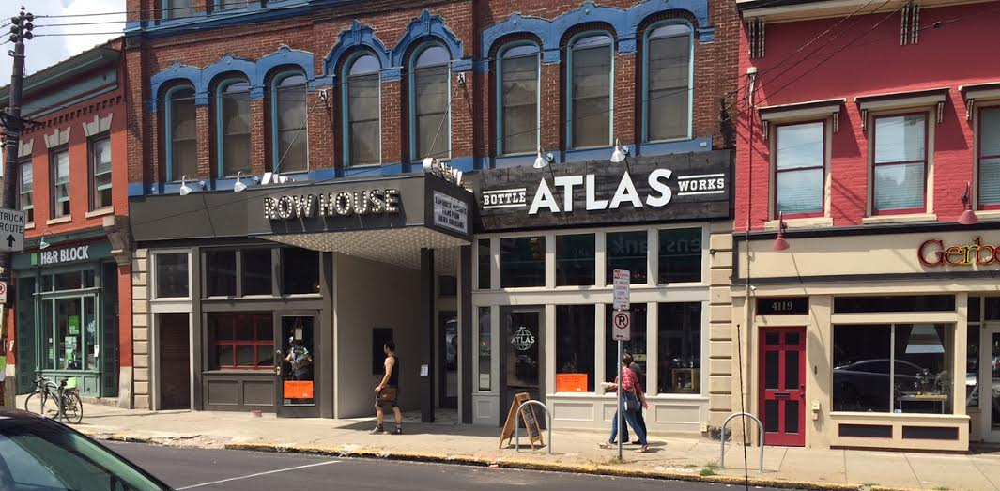
Wednesday, August 19th
6:30 PM
Stephen Foster Community Center
286 Main Street

The restaurant Smoke, currently BYOB, has applied for a liquor license for use in their restaurant.
Additionally, Atlas Bottle Works has applied for an extension of premises of their current liquor license to allow for two small tables and chairs on Butler Street in front of the business.
The owners of Smoke and Atlas, as well as the building owner, will be at the meeting to present plans, and to address questions and concerns regarding the liquor license applications and also any other issues relative to the business or building.

Please call Lawrenceville United at 412-802-7220 or email info@LUnited.org for more information.

