ATTENTION RESIDENTS AND BUSINESS OWNERS
A Meeting will be held regarding the proposed expansion of
The Round Corner Cantina (3718-3720 Butler).

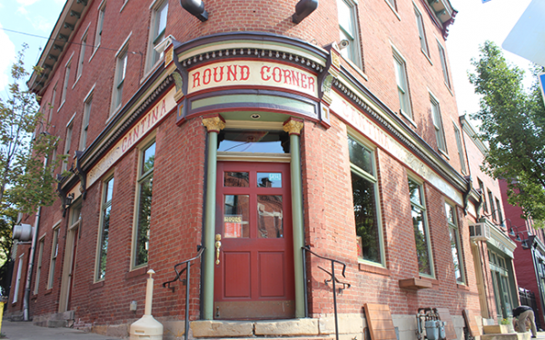
Tuesday March 3, 6:30PM
St. Augustine’s Social Hall
220 37th Street
The Round Corner Cantina, and owner Derek Burnell, has proposed an expansion to create a 3rd floor dining/ event space, The Ballroom. Owners have proposed to change the uses of the building from “hotel” to “restaurant limited.” As part of the expansion, owners will seek approval from the city’s Zoning Department and will also be also be purchasing a new liquor license for the building – to license both the 1st floor and 3rd floor spaces. The transfer of the new license to this location must first be approved by City Council, and then by the Pennsylvania Liquor Control Board. As part of our community process, you are invited to attend this meeting to meet the owner, to review what has been proposed, and to provide input and feedback.
Please call Lawrenceville United at 412-802-7220 or email info@LUnited.org for more information.

