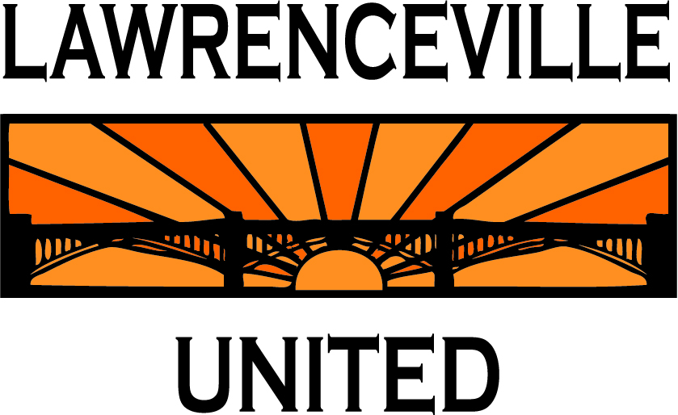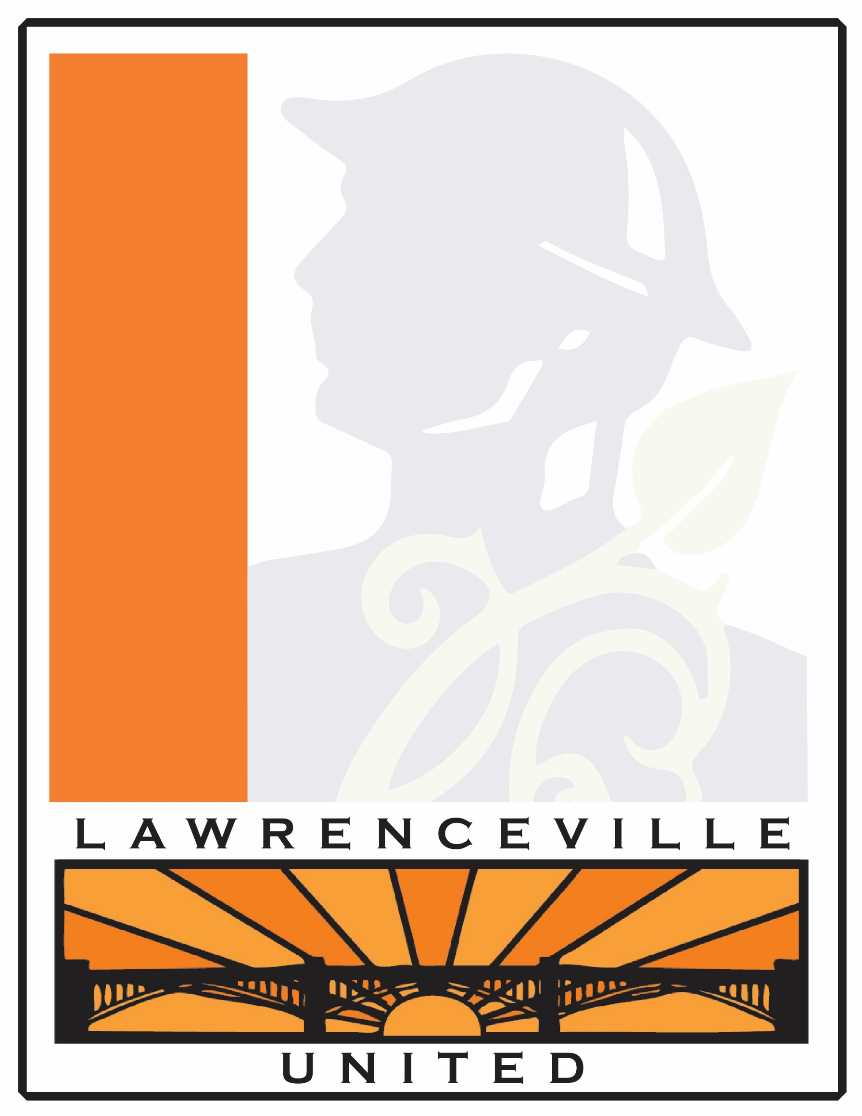

Community Meeting - RIDC Proposes New Building for Heppenstall Site

**March 7th, 2016**

**6:30 pm**

**Goodwill**

118 52nd Street

(multi-purpose room)

Pittsburgh, PA

RIDC, a regional nonprofit real estate developer, is proposing to build and own a 64,000 sq ft building on a portion of the former Heppenstall Steel Industrial site (at 47th/ Plum Way). The new facility will offer flex office/ high-bay space targeted to robotics and high-tech tenants.

RIDC will present their plans as part of a community meeting co-facilitated by LU and LC. Please attend with question/ concerns and to provide feedback for the developer.

If you need childcare during the meeting, please RSVP by March 4 to 412-802-7220. If you are unable to attend, you can still submit feedback on the plans by emailing [info@lunited.org](mailto:info@lunited.org).

Residents can call Lawrenceville United at 412-802-7220 with any questions or concerns. Meeting notes will be posted on lunited.org.

