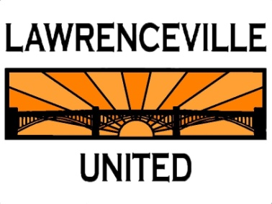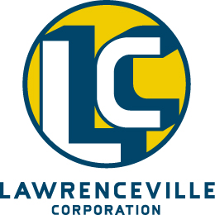
4412 Butler Street
Information Sheet
People
Property Owners: Butler Street Holdings LP
Prospective Business Owners:
Owners:
License Manager: TBD

Initial Timeframe: Opening May 2017

Place
Size: ~2400SF
Zoning: LNC
Site Plan: Presented at meeting

Necessary Approvals
Building Permit: Yes
Occupancy Permit: No
Liquor License: City of Pittsburgh license purchase under way

Business Overview
Reps from LU and LC met with Butler Street Holdings LP to request specific information pertaining to the proposed business and its operation. The following information has been provided in response to this request:
Ownership Principles / Vision: Light Italian Sandwiches, Salads & Pastas
Target Audience / Customer Demographic: All demographics, ages, and socioeconomic backgrounds
Days / Hours of Operation: 7 days/ 11am – 11pm
Hours Selling Alcohol: 11am – 11pm
Alcohol Menu / Price points: Full Bar, but heavy on Wine/Beer
Food Menu / Price points: Salads/Sandwiches – TBD ; Pastas/Mains - TBD
Number of Employees: 40
Entertainment: TBD
Site Plan / Façade/ Interior Improvements: Presented at meeting
Parking: None provided, not required by zoning.
Number of Dining Tables / Number of Seats at Bar: TBD
Security / Video Cameras: Yes
Signage: Yes
Smoking Policy: No Smoking
Private Events: Yes
Kid Friendly?: Yes
Recycling: Yes
Noise/ Volume Levels: Kept to minimum

Owner and Partner Information:
TBD

Why Lawrenceville?
This is the best location and opportunity to open a restaurant in Western Pennsylvania.

