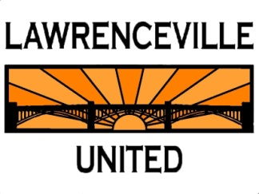
Please Join Us
December 5, 2012
6:30pm
St. Mary’s Lower Lyceum
330 45th Street

Community Meeting Regarding Heartland HOMES PROPOSED Development of
31 new single family attached dwellings @ Davison Street
(on the property owned by the Catholic Cemeteries Association/ Diocese of Pittsburgh.)

We facilitated a meeting on November 7, 2012 to discuss this project and many residents expressed an interest in meeting again as the community to discuss concerns. The developers continued their previously scheduled hearing from November to December 13, 2012. We will discuss their project and this hearing at the meeting on Wednesday. We will also discuss the Cemeteries Association’s request to vacate the top of 46th Street to which LU has objected through a formal petition.

Please call LU with any questions or concerns regarding the project or meeting at 412-802-7220 or email info@lunited.org

