IMPORTANT MEETING for LAWRENCEVILLE RESIDENTS and BUSINESSES
regarding the proposed redevelopment of 5251 Holmes Street (McCleary School).

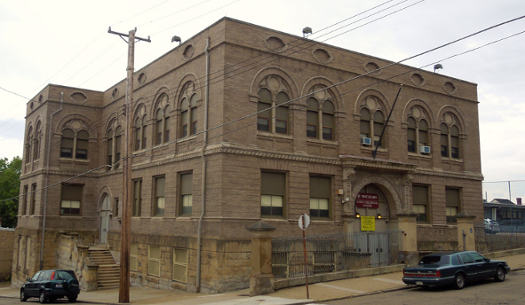

Tuesday, October 8, 2013
6:30 pm
Goodwill Industries
118 52nd Street

We have moved this month’s block watch meeting to Goodwill.
In addition to normal block watch presentations and discussions, E Properties & Development will be presenting their proposed plans regarding the residential redevelopment of McCleary School.

Please call Lawrenceville United at 412-802-7220 or email info@LUnited.org for more information

