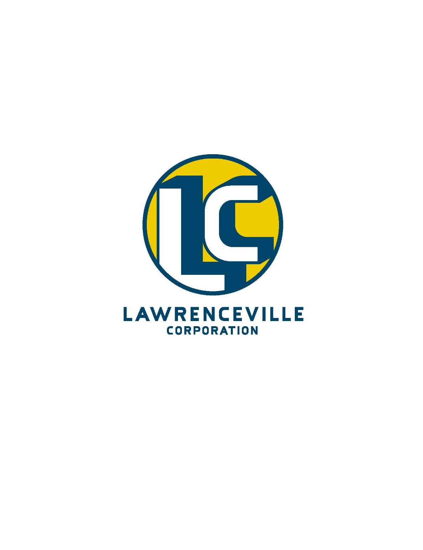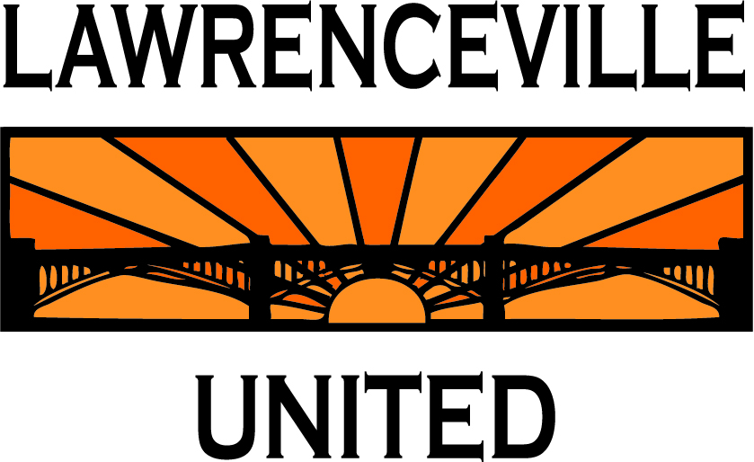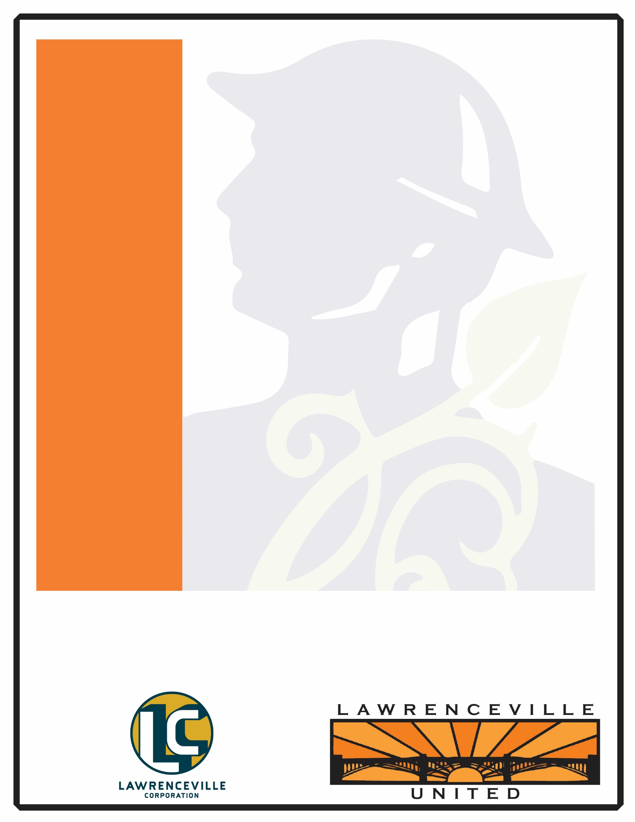

Date:

September 20th, 2016

7:00 pm

Location:

St Mary’s Lyceum

Residents & business owners welcome!

You’re Invited to a Community Meeting on

A restaurant is planning to be opened at address**>**. They have applied for a special exception in the LNC zoning district to use the first floor as a restaurant.

As part of the community process, you are encouraged to attend a meeting to learn more about their business. The meeting will take place at the regularly scheduled 6th Ward Block Watch on **Monday, July 25th at 7 PM at Pints on Penn, 3523 Penn Avenue**.

Please call Lawrenceville United at 412-802-7220 or email info@LUnited.org for more information.