IMPORTANT MEETING for LAWRENCEVILLE RESIDENTS and BUSINESSES
regarding a New Restaurant on the first floor of 4300 Butler Street that will require zoning and liquor license approvals.

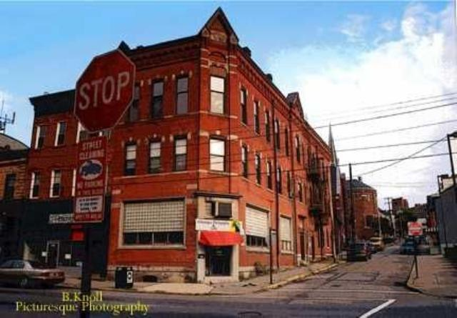
Wednesday, June 20, 2012
6:00 pm
St. Mary’s Lyceum
329 45th Street
Tender Bar & Kitchen, LLC (Owners: Jeff and Erin Catalina Owners of Verde Mexican Kitchen & Cantina) has applied for a Special Exception from the Zoning Board for use of a current vacant space on the first floor of 4300 Butler Street as a restaurant (general). The owners will also be applying for an intermunicipal transfer of a liquor license which will require City Council approval in addition to the standard PLCB approvals. You are invited to attend to meet the owners and to better understand what is being proposed in your neighborhood.

Please call Lawrenceville United at 412-802-7220 or email info@LUnited.org for more information

