IMPORTANT MEETING for LAWRENCEVILLE RESIDENTS and BUSINESSES
regarding the proposed construction of 234 38th Street & 234.5 38th Street requires zoning approval.
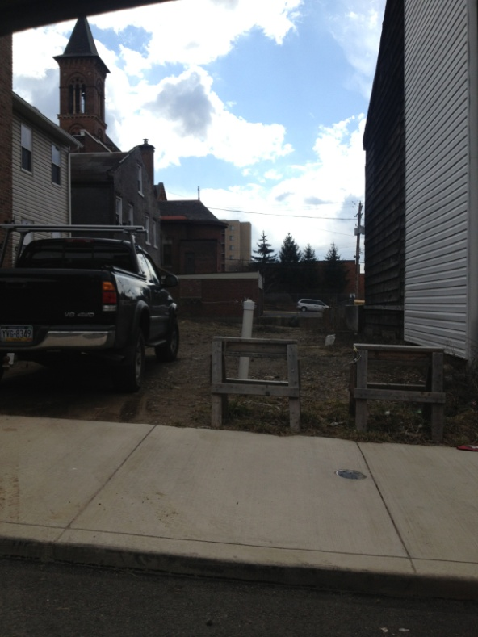

E Properties and Development LLC is building 2 new 3-story single-family dwellings with one parking pad in the rear.
They are seeking Variance 903.03.D.2:
- Minimum 1800 sq. ft. lot size required, 1200 sq. ft. requested
- Minimum 15 ft. front setback for unit 2 required, 0 ft. requested
- Minimum 5 ft. interior side setback required, 0 ft. requested
- Parking Pads: minimum 2 ft. rear setback required, 0 ft. requested and minimum 5ft. interior side setback required, 0ft one and 3.6 ft. another side requested.
E Properties will present their plans to the 6th Ward/ Lower Lawrenceville Block Watch on Monday March 25th @ 7p @ the St. Augustine’s Auditorium (220 37th Street)
Please call Lawrenceville United at 412-802-7220 or email info@LUnited.org for more information

