IMPORTANT MEETING for LAWRENCEVILLE RESIDENTS and BUSINESSES
regarding the proposed redevelopment of 174 43rd Street.

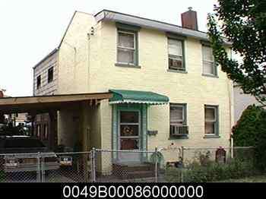

Monday, November 3, 2014
6:30 – 7:30 pm
Ice House Conference Room
100 43rd Street
(enter at the main door with call box – dial the Lawrenceville Corp on call box for entrance, proceed to 2nd floor, Suite #207)

Jerry Casale has applied for zoning variances to build two new construction single family attached dwellings at 174 43rd Street (after demo of the current structure). The project calls for relief from the Zoning Code’s minimum interior setback and maximum height requirements:

Variance: 903.03.E.2 minimum 5ft interior side setback required and 0ft requested
maximum height 3 stories permitted and 4 stories requested
The project is scheduled to be reviewed by the Zoning Board of Adjustments on Thursday, November 6, 2014.

Please call Lawrenceville United at 412-802-7220 or email info@LUnited.org to RSVP for meeting or for more information.

